PROBLEM 1

***a) Compute a new variable lnreturn for log returns by using the formula lnreturn = log(ret+1).***

ANSWER:

Please refer to the code!

***b) Compute the sample mean, standard deviation, skewness, excess kurtosis, minimum, and maximum of the log-return series.***

ANSWER:

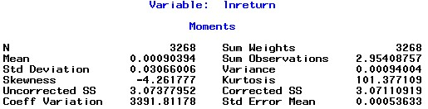

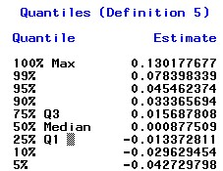

C:\Users\felix\Dropbox\courses\csc 425\homework_1\1-A-4.jpg

Mean = 0.00090394

Std Deviation = 0.03066006

Skewness = -4.261777

Excess Kurtosis = 101.377109

Minimum = -0.731206742

Maximum = 0.130177677

***c) Based on the descriptive statistics values, the histogram and the qqplot, what can you say about the distribution of the log returns?***

ANSWER:

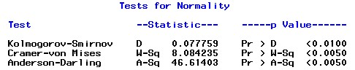

From the normality test, we could see that one dimensional K-S test clearly accepts the null hypo, saying that it is a normal distribution. Also, we could infer from the quantiles dist above that the distribution of important quantiles is nearly symmetrical (e.g. 90% quantile is 0.333, while 10% quantile is 0.296, which is close to 0.333). The histogram and qqplot also confirm it,

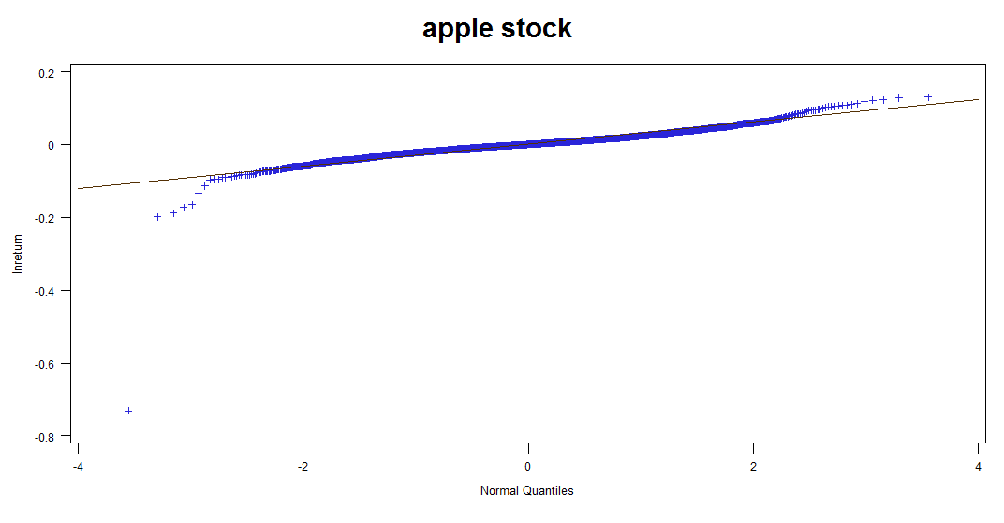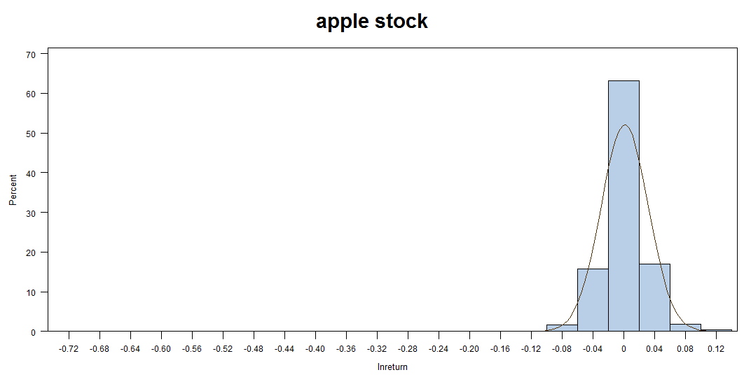

The skewness is -4.26 and the excess kurtosis is 101.38, which indicates that the distribution is negatively skewed with positive fat-tail, which is the same as shown by the two graphs.

***d) Test the null hypothesis of perfect symmetry at 5% significance level.***

ANSWER:

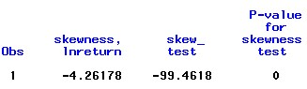

From the result of skewness test, we could see the p-value of it is zero, telling us that we could reject the null hypo that the the distribution is symmetry.

***e) Test the null hypothesis of excess kurtosis equal to zero (normal tails) at 5% significance level.***

***ANSWER:***

***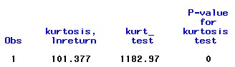***

From the result, we could reject the null hypo, which states that the distribution has a normally distributed tail.

***f) Test the null hypothesis that the log returns are normally distributed. Use the Jarque-Bera test*.**

**ANSWER:**

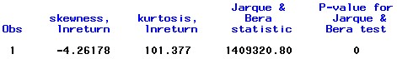

From the result above, we conclude that since the p-value is zero, the null hypo that it is a normal distribution is rejected.

PROBLEM 2

**a) Analyze distribution of inflation rates using a histogram and a quantile plot.**

ANSWER:

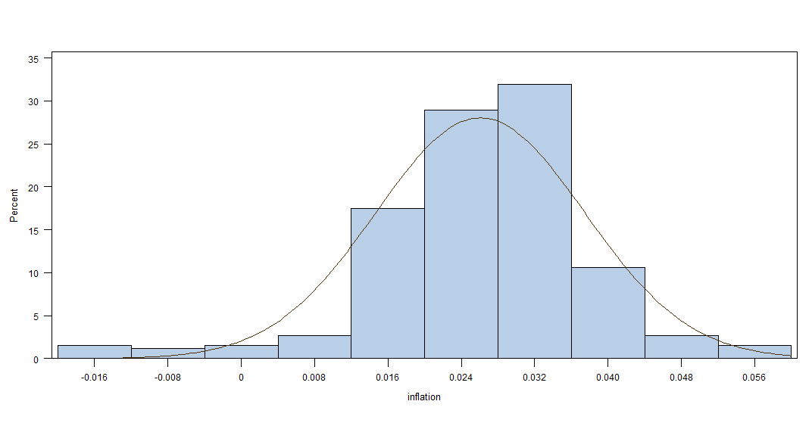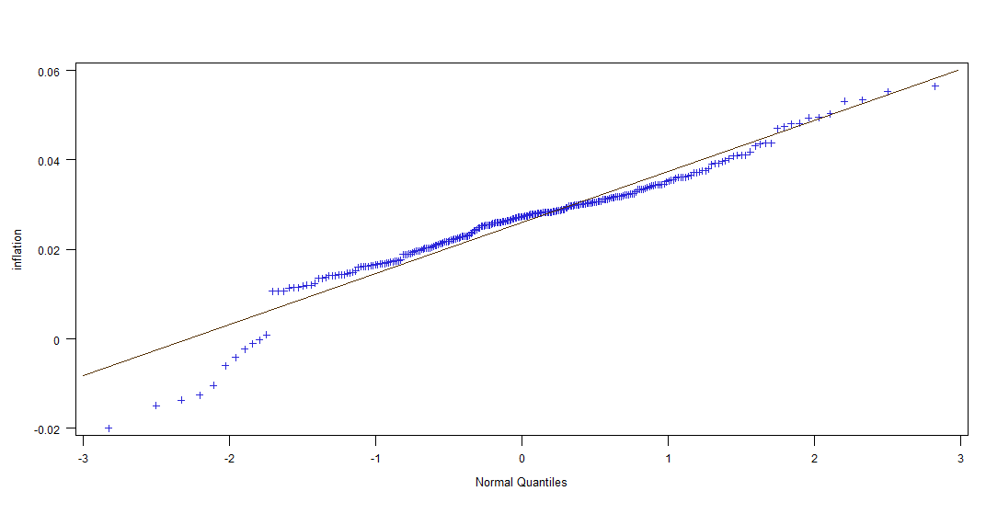

The QQplot and histogram show that the inflation rate has a mean of around 0.025. There are several extreme outliers on both sides of the distribution. I would not say it is a normal distribution given the result of QQplot.

**b) Describe the distribution of inflation rates in terms of symmetry/skewness and tails.**

ANSWER:

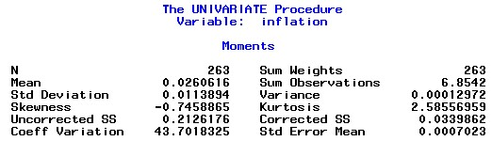

Skewness is -0.746 and Kurtosis is 2.59, saying that the distribution is negatively distributed around its mean, 0.026. It has positive fat-tail.

**c) Test the hypothesis of normality using the Jarque Bera test at 5% level.**

ANSWER:

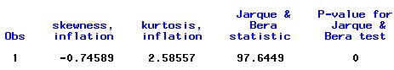

From the graph above, we could infer that the null hypo that it is a normal distribution has been rejected.

**d) Is the result of the test consistent with your answers for points a) and b)?**

ANSWER:

I think it is the same as implied by a) and b) except that I am not sure about the conclusion by see the histogram.

**e) Create a time plot for the inflation rate data. Make sure the plot is correctly labeled and nicely titled. Analyze the time trend displayed by the plot, and discuss if data show any striking pattern, such as trends or seasonality?**

ANSWER:

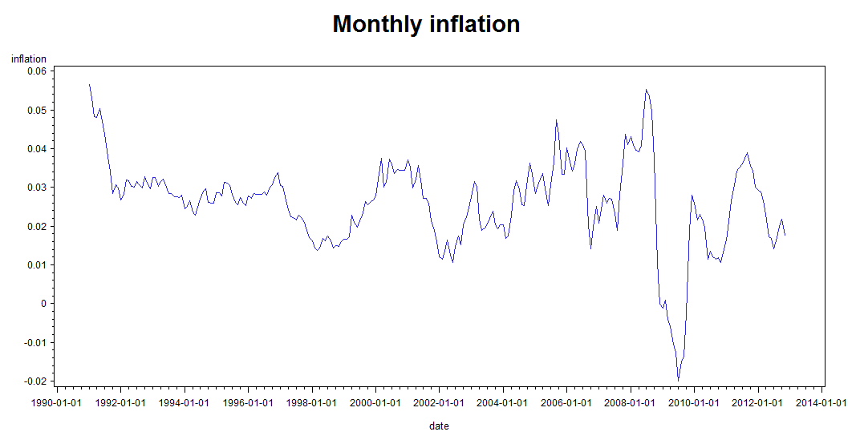

The plot firstly shows that, except for the period between year 2009 and year 2010 of financial crisis, the inflation rate always goes between 1% and 4% with a mean around 2.0% to 2.5%. Second, the inflation rate for almost every January is very likely to go up, a seasonality that maybe corresponds to the Christmas holiday shopping.

**f) Compute and plot the first 15 lags of ACF and discuss if the series shows evidence of serial correlation.**

**ANSWER:**

**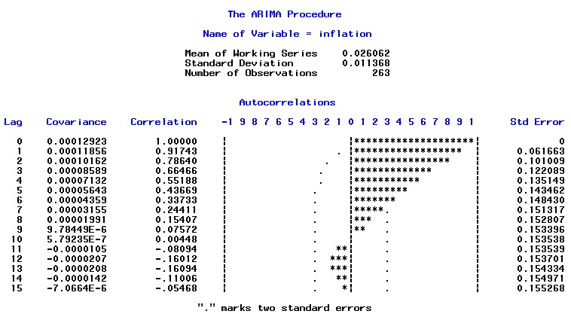**

From the result, we could see that there are evidently serial correlation prove can be identified, autocorrelations for lag 1 through 6 lagged period are significantly different than zero.

**g) Compute the Ljung Box test to evaluate if the inflation rates are serially correlated.**

ANSWER:

**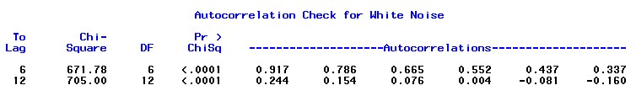**

From the result we could see that the null hypo that 6 lagged order and 12 lagged order correlations are zero is rejected.

**h) Evaluate the largest order of the serial correlations that are significantly different from zero.**

ANSWER:

From the graph of question f), we could see that the largest order that significantly than zero is 6th lag.